Mody University of Science and Technology, Laxmangarh-Sikar, Rajasthan
School of Liberal arts and Science
Department of Forensic Science
Event Report
Forensic Fusion 1.0 - Evidence Hunt and Moot Court Act Competition
Date: April, 26th, 2024

Introduction:
Forensic Fusion 1.0, an amalgamation of intellectual prowess and forensic expertise, unfolded its inaugural chapter at the esteemed Mody University of Science and Technology. The event, held on April 26th, showcased two riveting competitions: the Evidence Hunt and the Moot Court Act Competition. Hosted by the Department of Forensic Science, the event attracted participants from across the state, fostering an atmosphere of academic rigor and competitive spirit. Around 16 teams were participated in this event in which 11 teams were came from the Vivekananda Global University (VGU) Jaipur, Rajasthan and rest 5 were from the Mody University itself. Each team were leaded by the 1 leader including 4 member students from UG and PG level both. The whole teams were participated in both leading events named as Evidence hunt and Moot Court Act Competition.
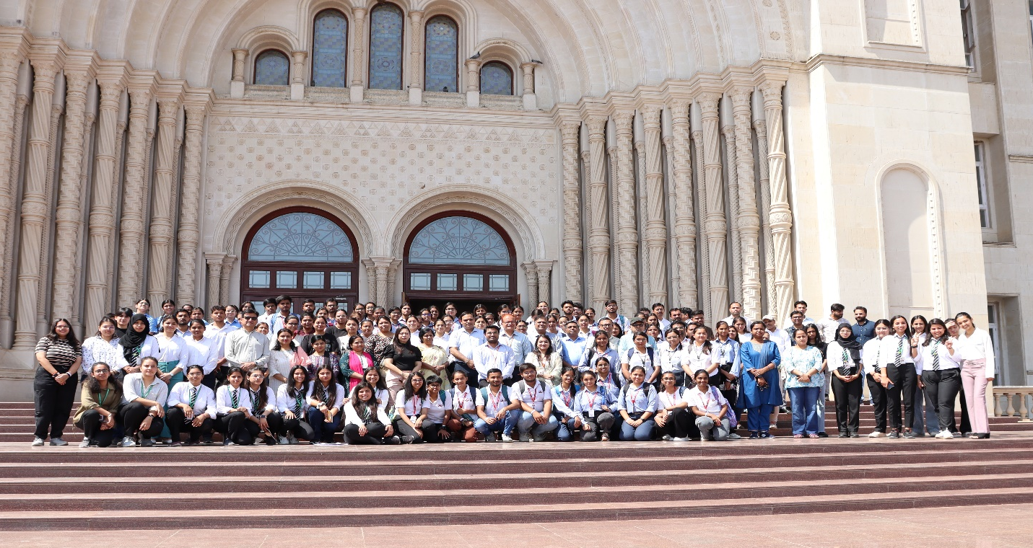

Inaugural Session:
First Session: At room 001 on the ground level, participants from VGU and other SLAS schools were welcomed to begin the session. Invited guests sang the University Kulgeet and Saraswati Vandana to open the session. Prof. (Dr.) Anil Sarolia, Dean of Academics, opened the session by highlighting the value of forensic science and its current requirements in the criminal justice system. Later, Prof. Bala, Dean of the School of Law, raised the issue of legal knowledge among young forensic buddies and the police system. Prof. (Dr.) Jitendra Binwal, Dean of the School of Liberal Arts and Science, extends a warm welcome to all attendees and emphasizes the critical role that forensic investigators play in solving crimes. He has also briefed the participants on the value of scientific research in presenting cases before honourable judges and has encouraged them to take part in the Evidence Hunt and Moot Court Act Competition. Later, HoD of Forensic Science Dr. Tilak Ram Chandrakar thanked the distinguished guests and attendees and gave a briefing on the Forensic Fusion 1.0 event's program.
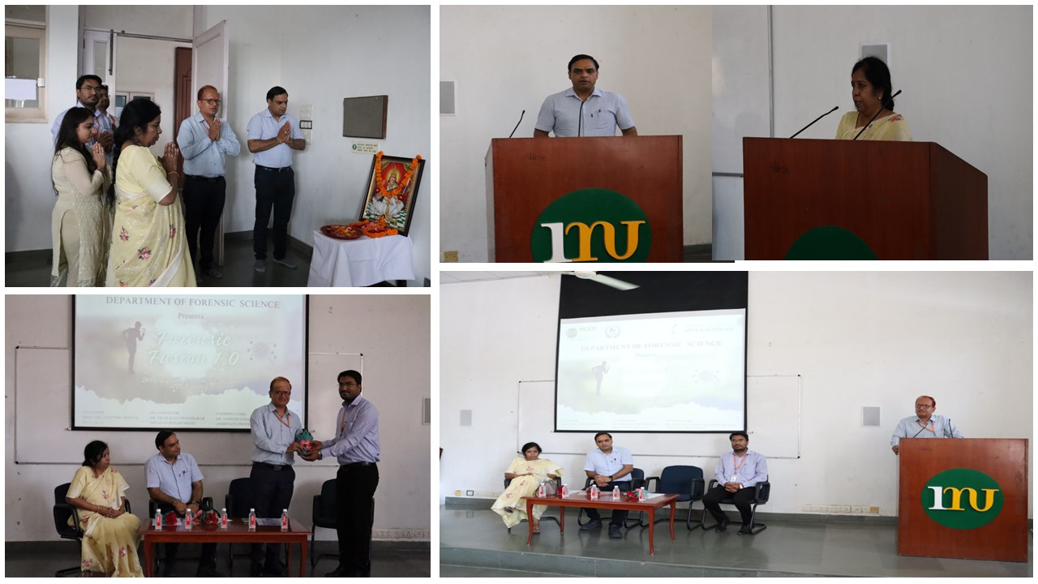

Evidence Hunt:
The Evidence Hunt kicked off the proceedings with an exhilarating display of forensic acumen and problem-solving skills. Participants, divided into teams, navigated through a series of intricate forensic scenarios, each laden with clues and challenges. From analysing crime scenes to deciphering cryptic evidence, the competition tested the participants' ability to think critically under pressure. To overcome the hhurdles, the teams showcased remarkable teamwork and resilience. The competition culminated in a gripping finale, where the top contenders engaged in a battle of wits to claim victory. Evidence Hunt: The team from VJU known as Crime Advocates 5.0 arrived and took first place in the competition. Teams Sherlock Holmes and Mystery Masters from MUST secured first and second runner-up positions, respectively, in order to solve the given clues, formulate a desired hypothesis, and create a crime scene by gathering and organising the evidence they found. The teams, which consisted of five people in total, respond to the questions posed in this portion by the corresponding judges. Dr. Tilak Ram, Prof. Navneet Joshi, and Prof. Harish Dhingra evaluated the events the teams produced and assigned a number based on their performance and hypothesis.
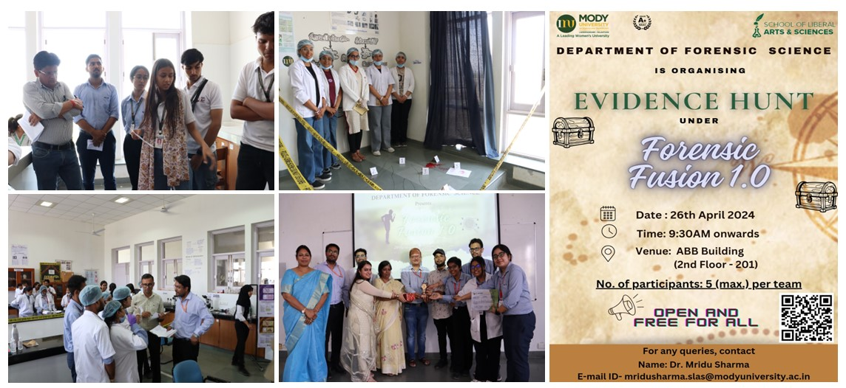
Moot Court Act Competition:
Simultaneously, the Moot Court Act Competition unfolded, offering participants a platform to hone their advocacy skills and legal acumen. The moot court session simulated a courtroom environment, where participants assumed the roles of prosecution and defence attorneys, presenting arguments and counterarguments with precision and eloquence. The cases presented ranged from complex forensic investigations to nuanced legal interpretations, challenging the participants to navigate through intricate legal frameworks while articulating their stance persuasively. The competition witnessed intense courtroom drama, with participants displaying commendable legal prowess and poise. The team from School of Law, Mody University of Science and Technology known as Furious finders and took first place in the Moot Court Act competition. Team Forensic Cadets and Crime Advocates from VGU secured first and second runner-up positions, respectively, in order to put the argue before the court formulated as Moot Court in the School of Law, Mody University of Science and Technology. The total 5 members were in each teams put the argue and respond to the questions posed in this portion by the corresponding judges. Prof. (Dr.) Chandan Bala, Dean SOL, Dr Neetu Nuwal, Assistant Professor School of Law, Prof. Jitendra Binwal, Dean School of Law evaluated the events, the teams produced and assigned a number based on their performance and argue on Shushant Murder case as a case objective for conduction of the moot court event.

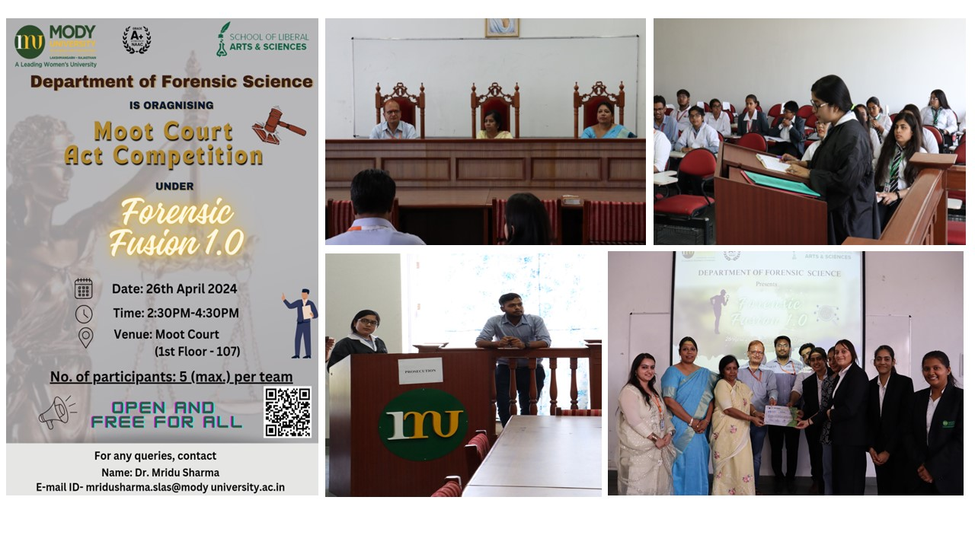
Highlights:
Forensic Fusion 1.0 was not merely a competition; it was a celebration of intellectual curiosity and academic excellence. The event provided a unique opportunity for students to engage with real-world forensic challenges and legal dilemmas, fostering a deeper understanding of the complexities inherent in the field of forensic science and law. The collaborative efforts of the organizing committee, faculty mentors, and enthusiastic participants contributed to the resounding success of the event. A special gathering of Mody School Students was arrived to attend the event along with their faculty members and witness the activities of participants in evidence hunt as well as Moot Court Act competition and learned the advancement and techniques of forensic on the ground and before ethe honourable court.
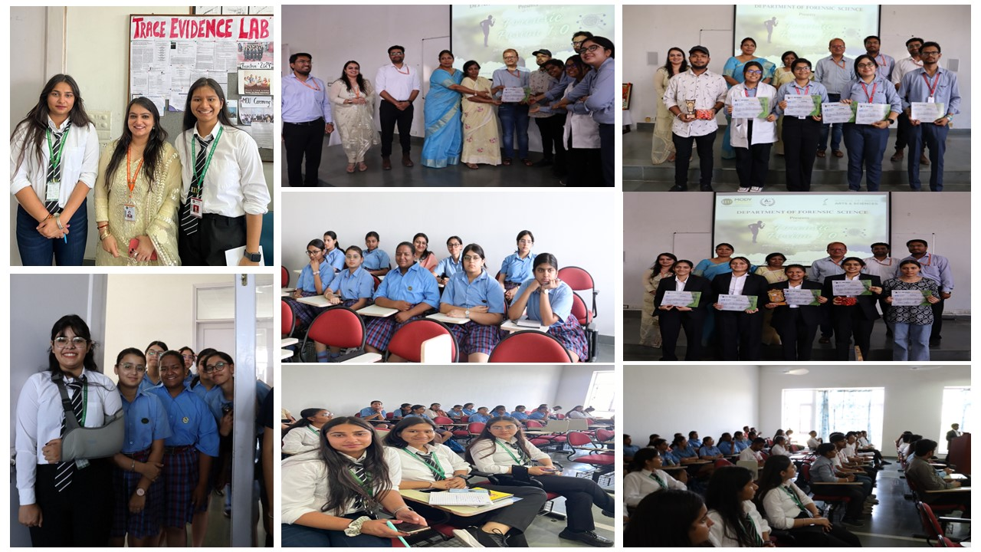
Conclusion:

As the curtains drew to a close on Forensic Fusion 1.0, the air was filled with a sense of accomplishment and camaraderie. The event served as a testament to the vibrant spirit of inquiry and innovation that defines the forensic science community. With its stimulating competitions and engaging discourse, Forensic Fusion 1.0 left an indelible mark on all those who participated, inspiring them to continue their pursuit of knowledge and excellence in the field of forensic science and law. The event was graced by dignified presence of Circle Officer Mr. Deelip Kumar Meena, Laxmangarh as representative of superintendent of Police District Sikar, Rajasthan. Mr. Meena appreciated the University for organizing these events and promoting the importance of Forensic and Court for getting Justice. He also admires the facilities available at university with special aspect to Research work and practical approach for students of Forensic Science. The event was well organized by the faculties of Forensic Science Dr. tilak Ram, Dr. Mridu Sharma and Dr. Sameer Saharan who organized these events with well manner. The event was well executed by the student of forensic Science, starting from registration, welcoming the guest and guiding them in each section to perform Evidence Hunt as well as Moot Court Act Competition event. Dean School of Liberal arts and Science Prof. (Dr.) Jitendra Binwal appreciate the team of Forensics including faculty members and students and also the teaching and non-teaching fraternity of School of Liberal Arts and Science. The event was covered by all the news agencies in local print media.

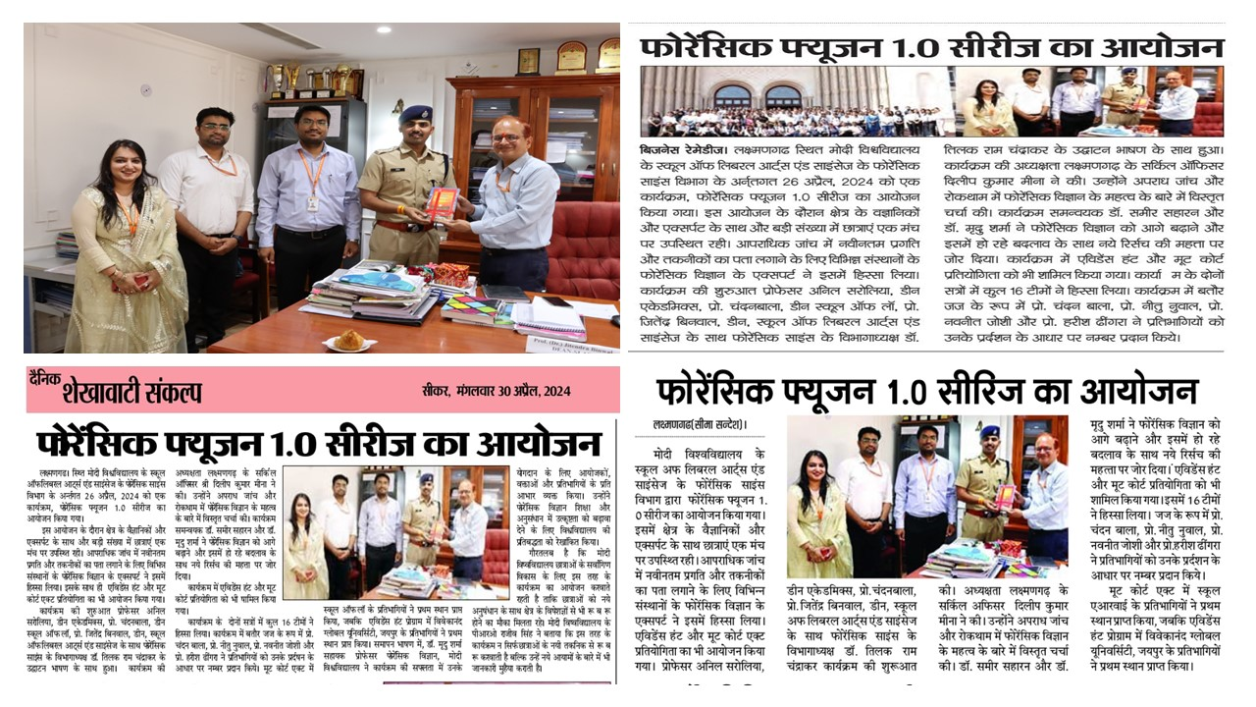

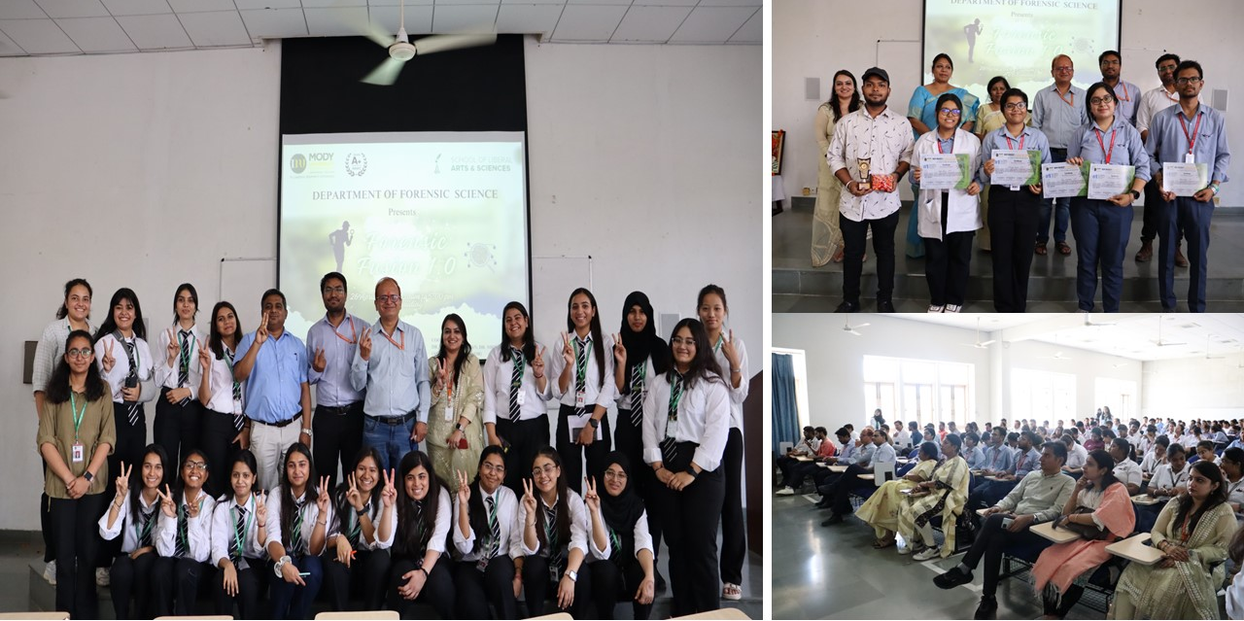

Event Convenor Event Co-Convenor
Prof. (Dr.) Jitendra Binwal Dr. Tilak Ram

Event Coordinators
Dr. Mridu Sharma & Dr. Sameer Saharan

